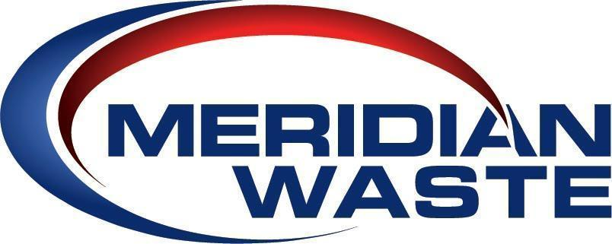

**FOR IMMEDIATE RELEASE**

**Meridian Waste Acquires Evergreen Environmental Partners Holdings, LLC & ADSI Holdings, LLC**

**Adding the States of Alabama & Mississippi to Meridian Waste’s Operational Footprint**

**Charlotte, NC** – September 3, 2024: Meridian Waste Acquisitions, LLC, a non-hazardous, integrated solid waste services company, announces that the company has acquired the stock of Evergreen Environmental Partners Holdings, LLC (EEP) & ADSI Holdings, LLC (ADSI) effective September 1, 2024. The two entities were holdings of BTG Pactual Strategic Capital. The acquisition expands Meridian Waste’s operational footprint within the Southeast, adding a MSW landfill, a transfer station facility and additional third-party transfer station operations as well as hauling, administrative and maintenance facilities servicing commercial, industrial and residential contracts throughout Alabama and Mississippi.

The acquisition will result in both strategic and financial benefits to the company and its private shareholders. The EEP/ADSI acquisition brings a network of high-quality assets into Meridian Waste’s Southeast environmental services portfolio. The Meridian Waste management team has demonstrated great success in acquisition integration by improving upon and growing acquired asset margins and cash flow and will continue to do so with this multi-state acquisition.

Specific assets comprised within the stock purchase include the Noble Hill MSW Landfill and EEP Transfer Station in the greater Huntsville, Ala. marketplace, 50+ municipal contracts (including exclusive residential collections and transfer station hauling operations) and commercial and industrial accounts serviced throughout Alabama and Mississippi.

“Meridian Waste is in full growth mode, as exhibited by the company’s announcement of its largest acquisition yet of these impressive Alabama and Mississippi assets,” stated Walter “Wally” Hall, Meridian Waste’s CEO. “Our management team is very familiar with the Alabama and Mississippi marketplaces from previous roles in the industry. We are confident that we can grow the solid base of business already built by Darren and Anthony Rizzo alongside the many dedicated team members of EEP and ADSI and with the continued support of our private equity partner, Warren Equity Partners. Together, we look forward to integrating these assets into our Southeast footprint and having Meridian Waste become a major part of the Alabama and Mississippi solid waste services industry.”

This will be Meridian Waste’s thirtieth acquisition since the company transitioned to private stock under the ownership of Warren Equity Partners (WEP) in April 2018.

**Image 1: Meridian Waste Logo**

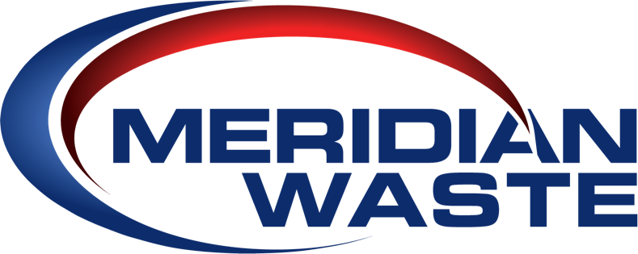

**Image 2: Meridian Waste Frontload Truck**

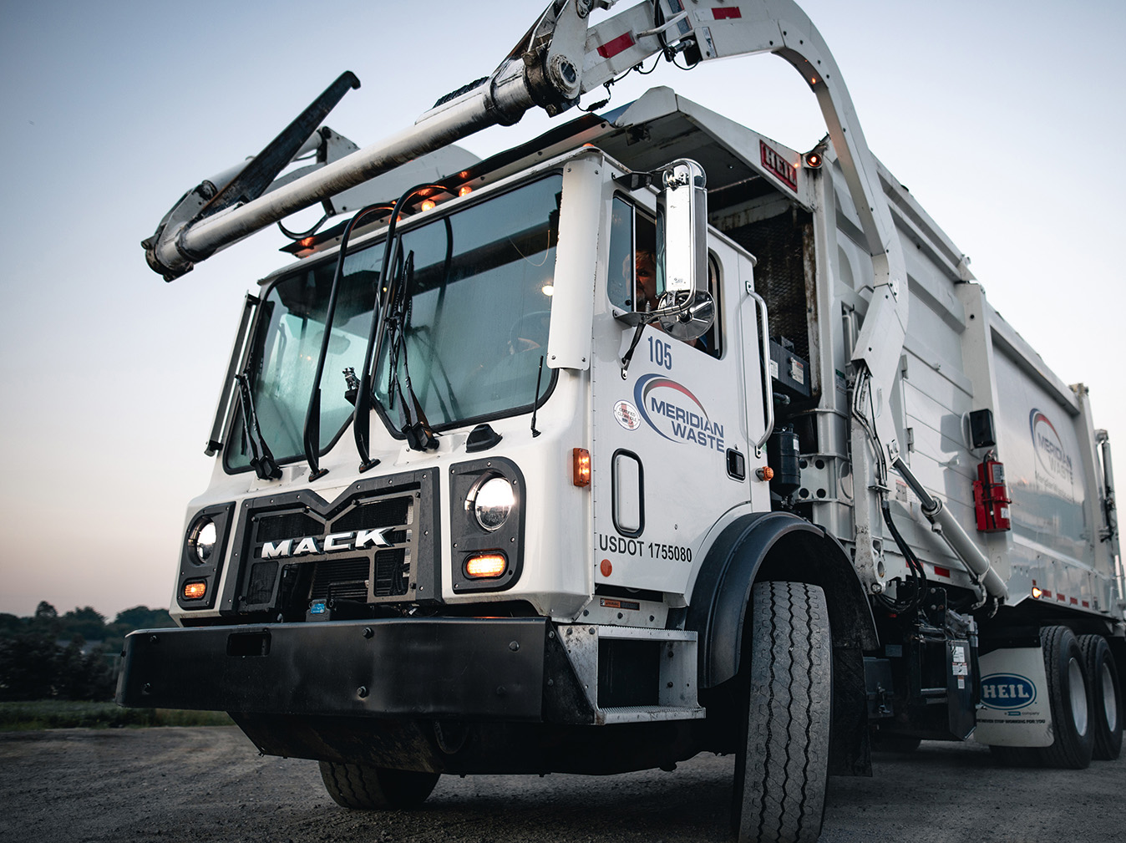

**About Meridian Waste**

Headquartered in Charlotte, N.C., Meridian Waste is a company defined by its commitment to servicing its customers, caring for and engaging its employees, and generating financial value for its shareholders while delivering a clean and healthy community. The company’s core waste business is centered on residential, commercial, and industrial non-hazardous waste collection and disposal. Currently, the company operates in Northeast Fla., St. Louis, Mo., Goldston, N.C., Raleigh, N.C., Greensboro, NC, Greenville, S.C., Knoxville, Tenn., Huntsville, AL, Central AL, North & South MS, Blacksburg, Va., Harrisonburg, Va., and Richmond, Va., servicing more than 524,520 residential, commercial, industrial, and governmental customers. In addition to a fleet of commercial, residential, and roll-off trucks, the company operates 31 hauling companies, eight transfer stations/materials recycling facilities (MRFs), three municipal solid waste landfills, and four C&D landfills in which 1,107,574 tons of waste are safely disposed of annually. For more information, visit [MeridianWaste.com](http://www.meridianwaste.com/).

**Media Contact:**

Mary O’Brien

(904) 616-5322

MObrien@MeridianWaste.com

###